**Chapter 7**

**ANALYSIS**

**7.1 Accuracy of prediction**

An analysis was made to check the accuracy of the prediction being done by the software. This is very important to know the realiabity of the application.

Referring to the Figure 7.1, three days traffic data of a junction under analysis (axatech) is taken. Average of which is calculated. Difference of the first data & average is evaluated. The worst case and the best case out of all the cases are inferred.

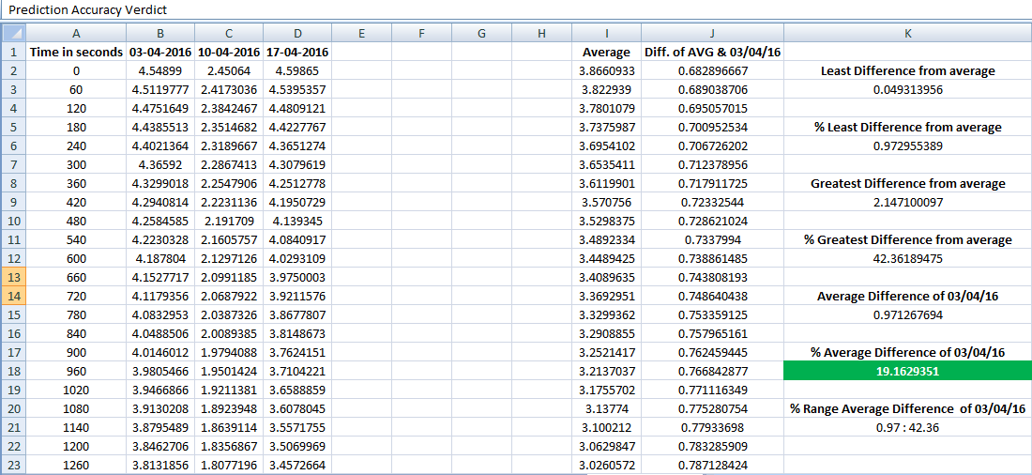

**Figure7.1: Accuracy analysis**

Percentage average difference and the range of percentage average difference of all three days data is calculated (Figure 7.1 &Figure 7.2). Same is shown in the figures.

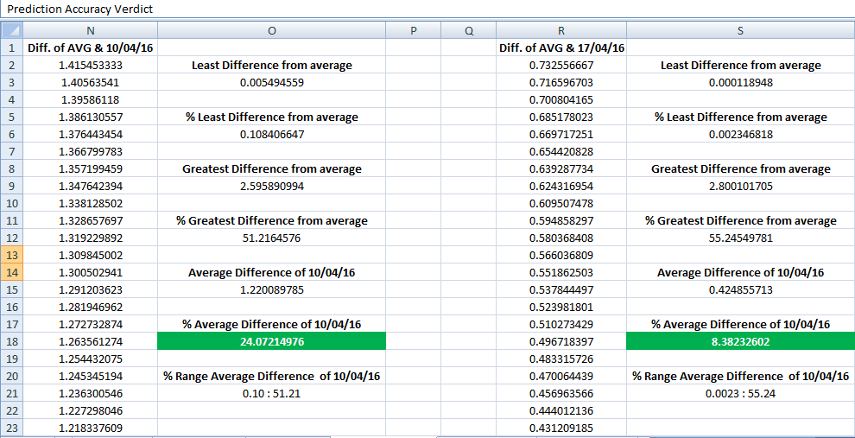

**Figure 7.2: Accuracy Analysis**

Prediction accuracy inferred from this analysis ranges from **75.92785024 - 91.61767398** which is obtained by average differences of all the three days of data put together. This analysis made, is for only 3 days of data, what we can theorize out of this analysis is that the accuracy of the prediction increases with the increase in the amount of data considered.

**7.2 Observation**

When the graph was plotted, there was a similar pattern seen for different days of data. Figures below shows the patterns obtained for different days in a week.

**Figure 7.3: Pattern for Sunday data**

**Figure 7.4: Pattern for Monday data**

**Figure 7.5: Pattern for Tuesday data**

**Figure 7.6: Pattern for Wednesday data**

**Figure 7.7: Pattern for Thursday data**

**Figure 7.8: Pattern for Friday data**

**Figure 7.9: Pattern for Saturday data**

All the charts have a similar kind of patterns plotted for same days of the weeks. This proves that the approach being used is reliable.

**7.3 Summary**

This chapter talks about the analysis made to show the accuracy range of the prediction made and its reliability.